**Project Design Phase-II**

**Data Flow Diagram & User Stories**

|  |  |
| --- | --- |
| Date | 03-01-2026 |
| Team ID |  |
| Project Name | BookStore |
| Maximum Marks | 4 Marks |

**Data Flow Diagrams:**

A **Data Flow Diagram (DFD)** illustrates how data moves within the BookStore platform. It captures how users interact with the system, how information flows between different components, and where the data is stored.

Example: DFD Level 0 (Industry Standard)

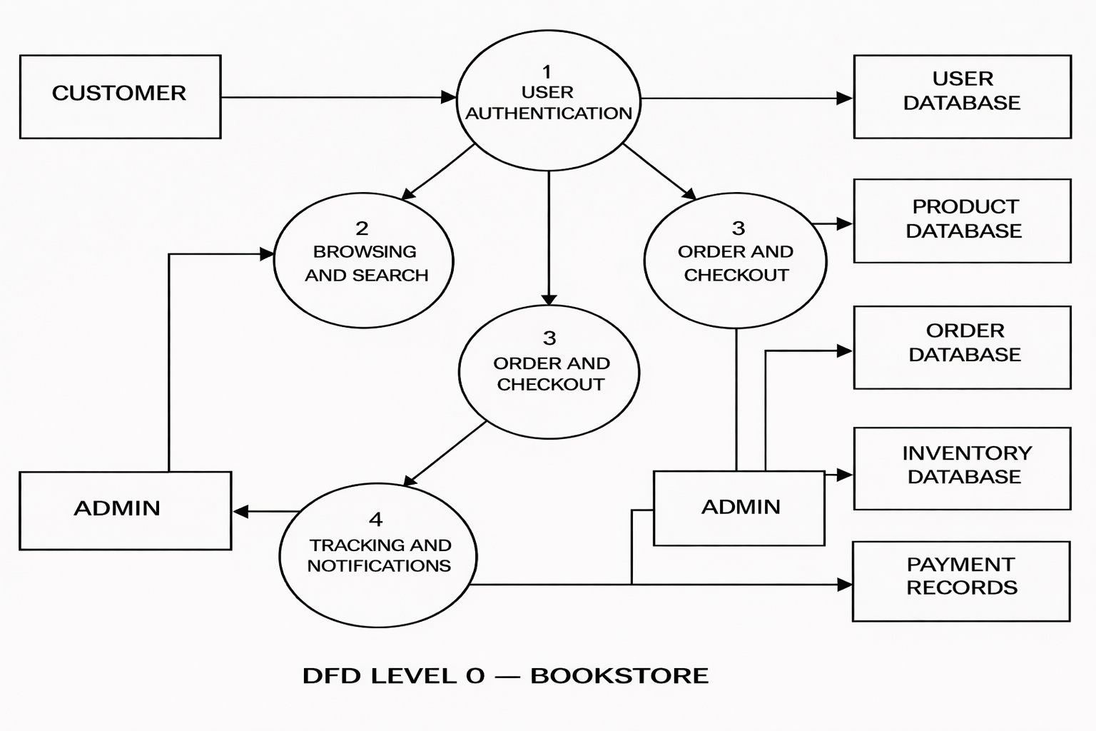

**User Stories**

**User Story Table - BookStore**

| **User Type** | **Functional Requirement (Epic)** | **User Story / Task** | **Acceptance Criteria** | **Priority** | **Release** |
| --- | --- | --- | --- | --- | --- |
| Customer | User Registration & Login | As a customer, I can register and log in to my account. | User is able to log in and access dashboard successfully. | High | Sprint-1 |
| Customer | Book Browsing | As a customer, I can browse books by category, author, or genre. | Books are displayed correctly based on selection. | High | Sprint-1 |
| Customer | Book Search & Filter | As a customer, I can search and filter books by price, author, and rating. | Search and filter return relevant results. | Medium | Sprint-2 |
| Customer | Book Details | As a customer, I can view detailed information about a book. | Book details page shows price, description, reviews, and availability. | High | Sprint-1 |
| Customer | Cart Management | As a customer, I can add or remove books from my cart. | Cart updates correctly with selected books. | High | Sprint-1 |
| Customer | Order Placement | As a customer, I can place an order for selected books. | Order is confirmed and order ID is generated. | High | Sprint-2 |
| Customer | Payment Processing | As a customer, I can make secure online payments. | Payment is successful and recorded in transaction history. | High | Sprint-2 |
| User | Order Tracking | As a user, I can track the status of my orders. | Order status updates are visible in dashboard. | Medium | Sprint-2 |
| User | Review System | As a user, I can leave reviews and ratings for purchased books. | Review appears on the book page. | Medium | Sprint-2 |
| Admin | Book Management | As an admin, I can add, update, or remove books. | Book catalog reflects changes immediately. | High | Sprint-1 |
| Admin | Order Management | As an admin, I can view and manage customer orders. | Order details and status updates are saved. | High | Sprint-1 |
| Admin | User Management | As an admin, I can manage users and handle reported issues. | User actions and reports are logged. | High | Sprint-1 |